**Sunkari Manohar**

**Assessment 6 – 04/01/2024**

**Azure Databricks**

* **Today we did ETL workload on Azure Databricks.**

First we need to search azure databricks in azure portal and we need to create a workspace.

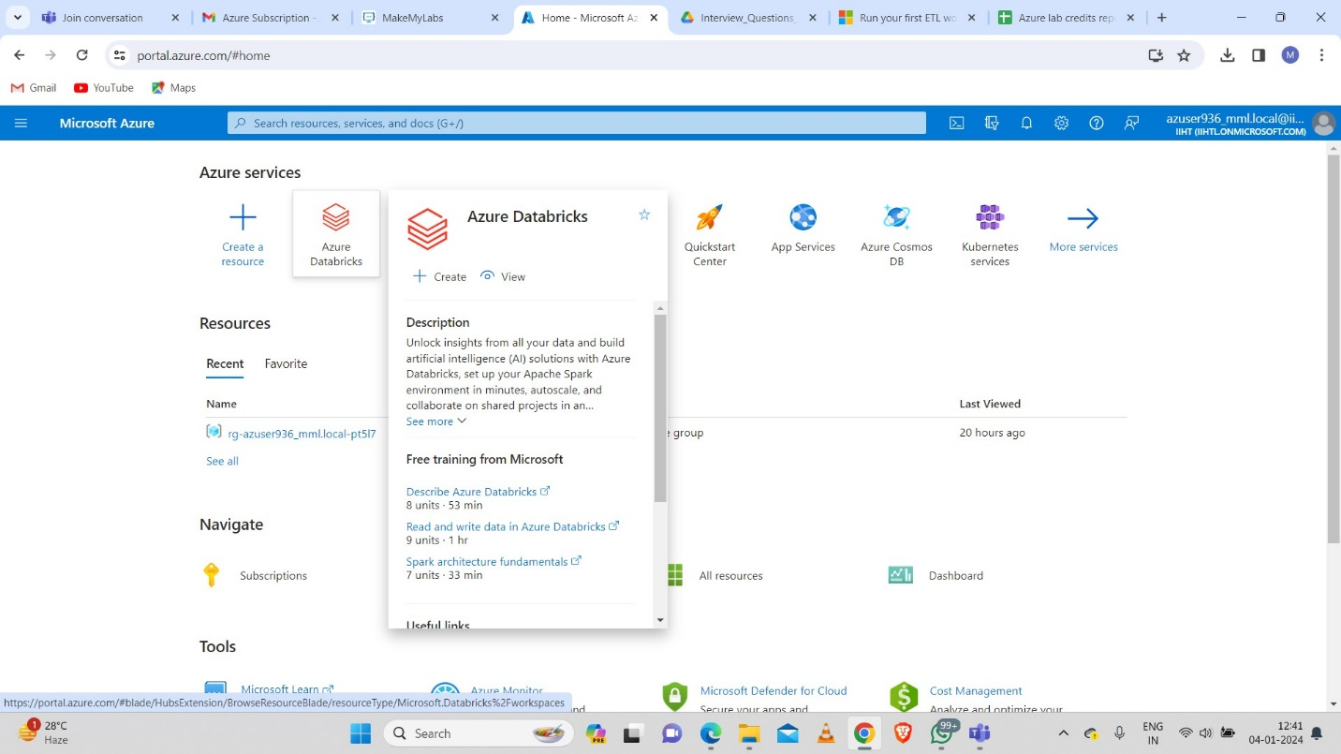

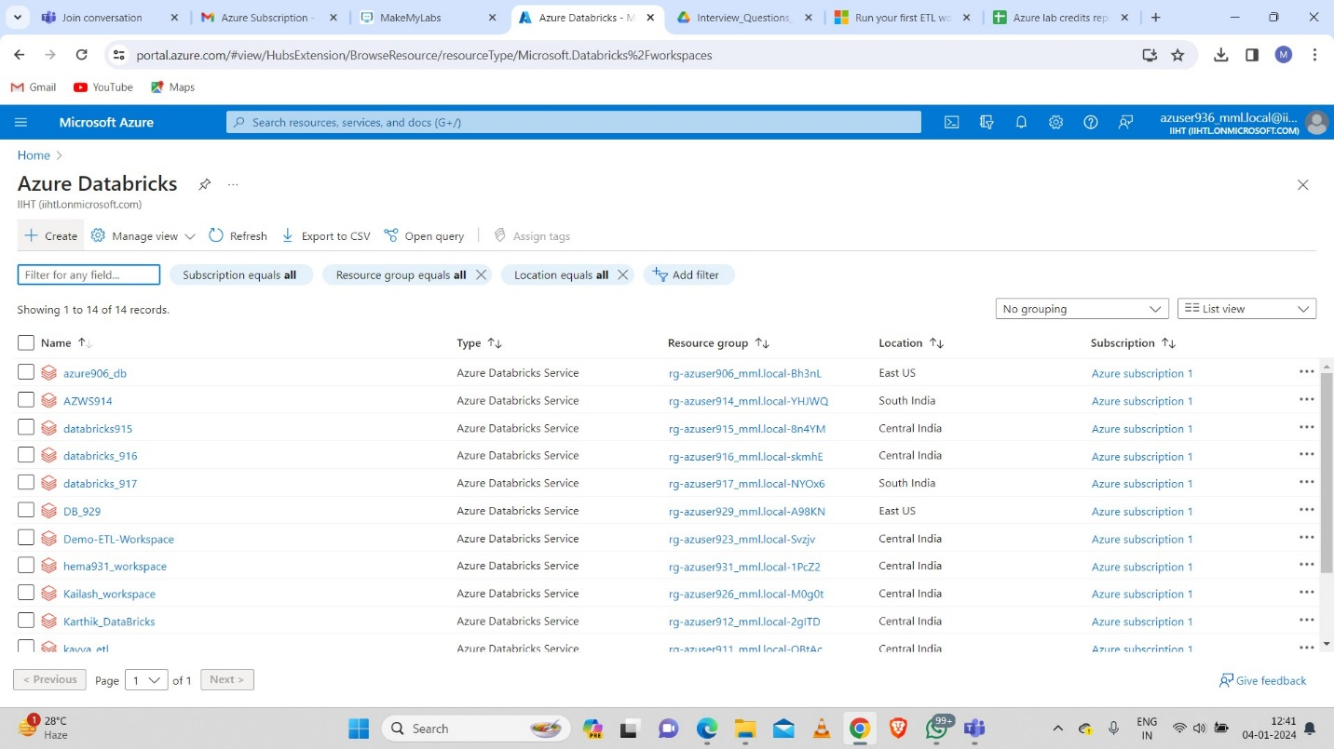

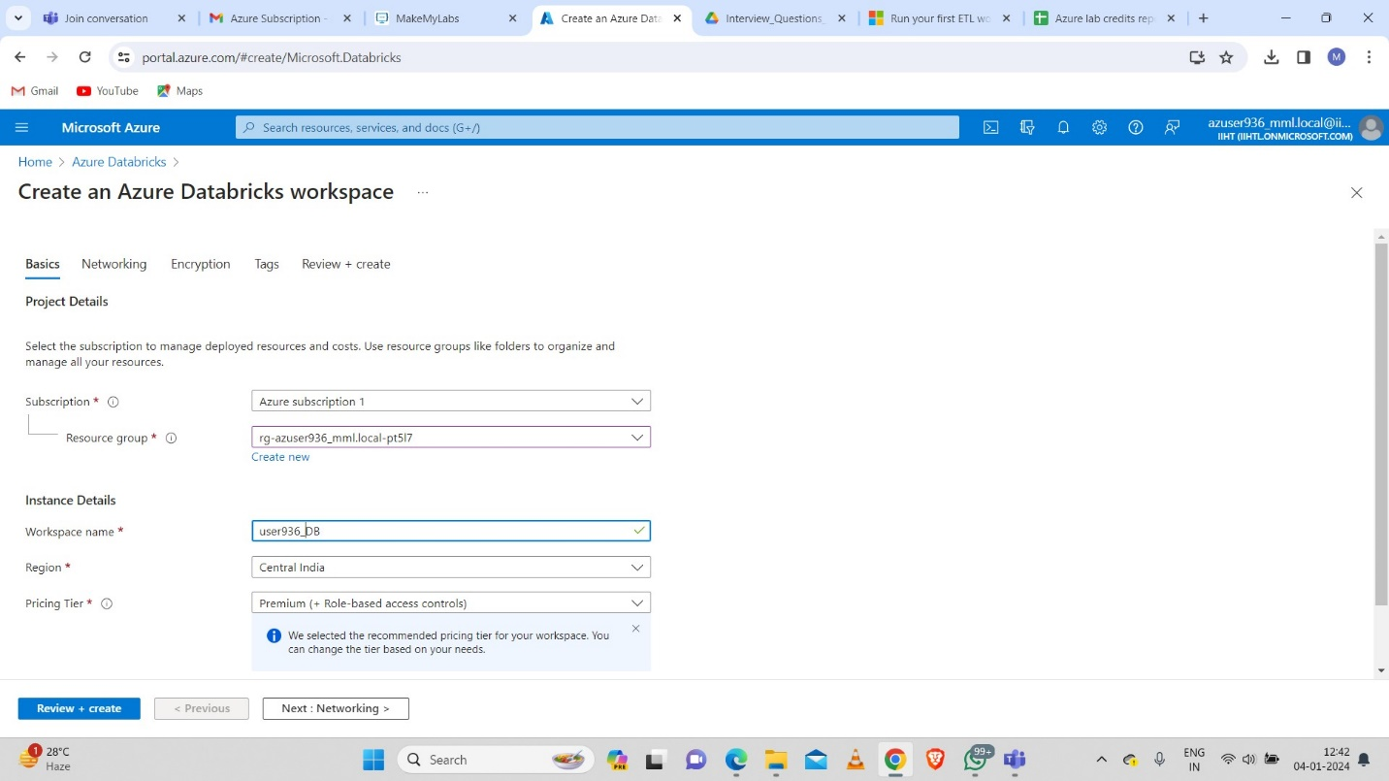

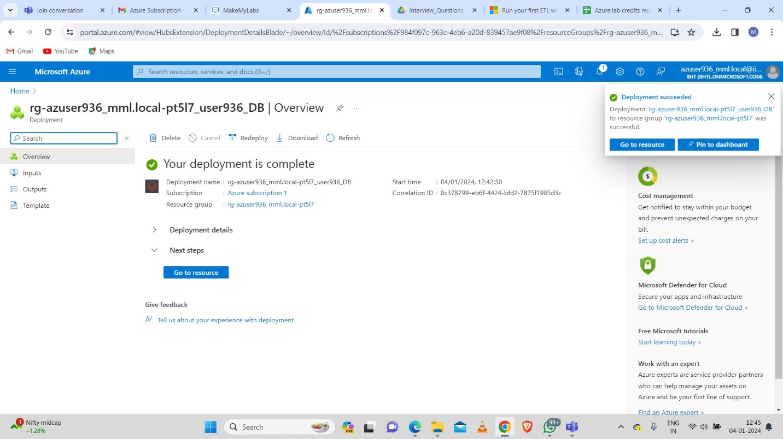

Now we need to launch the workspace.

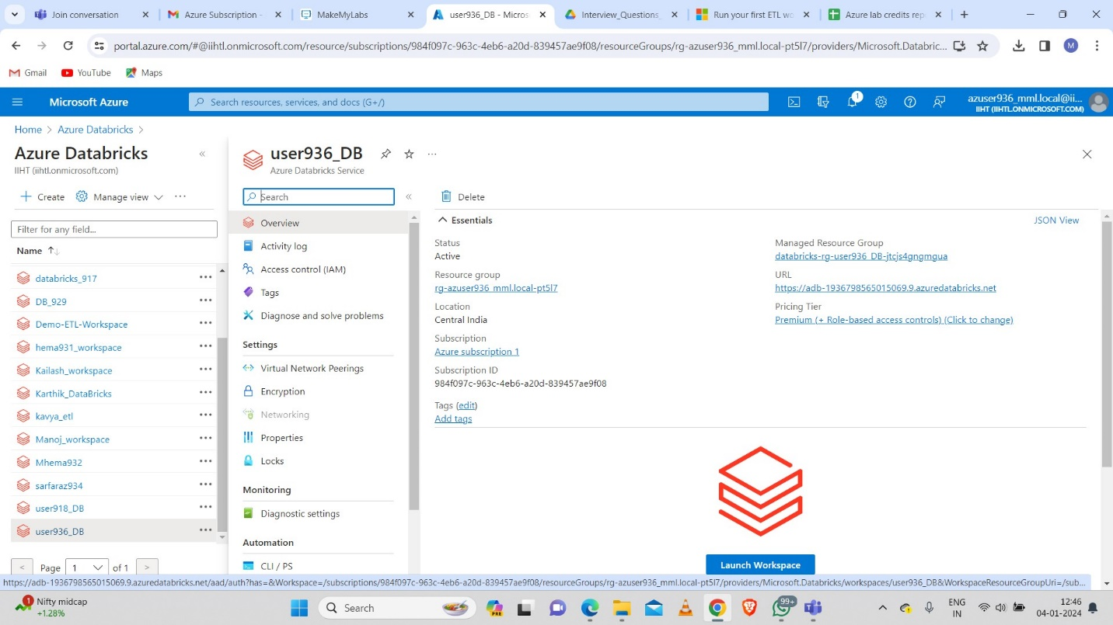

Step-1: Creating a Cluster

Click on “+new” tab and click on cluster to create a new cluster.

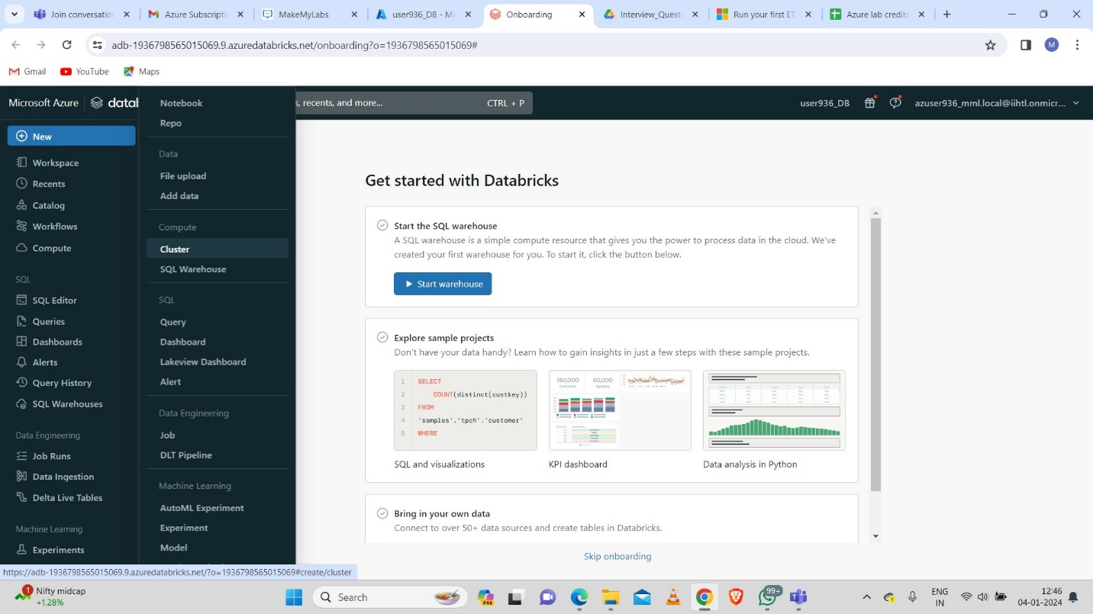

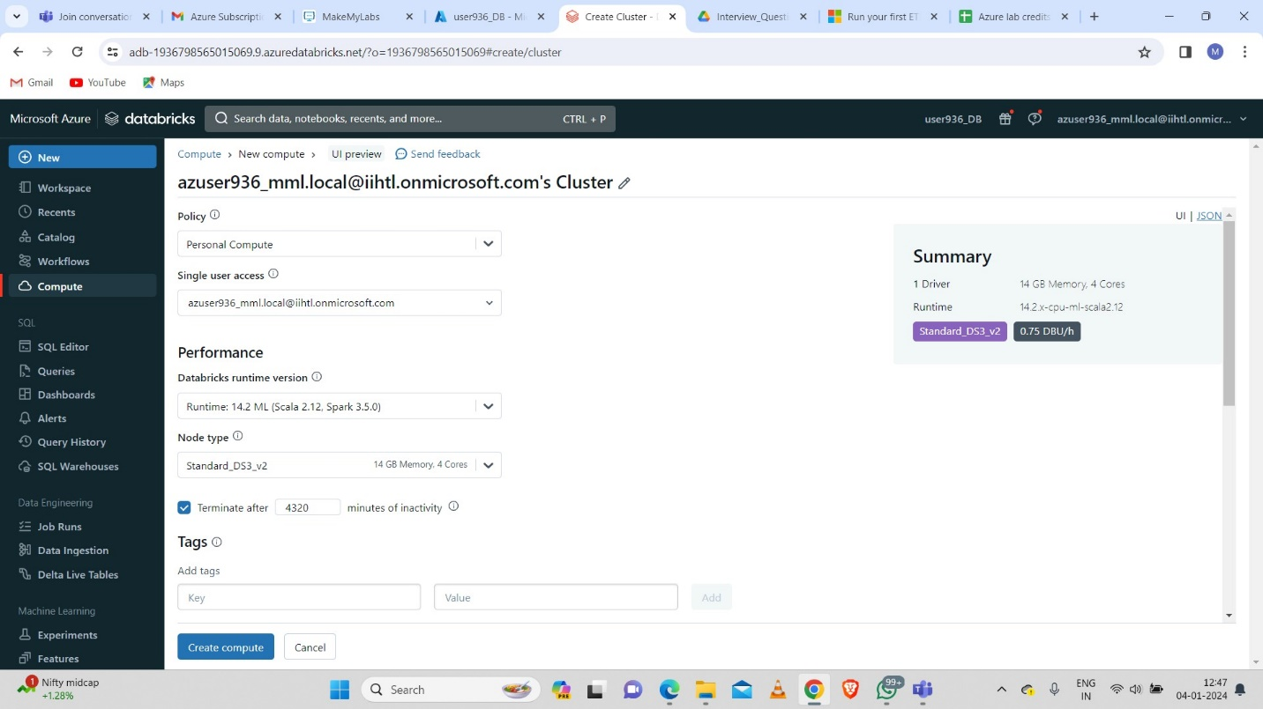

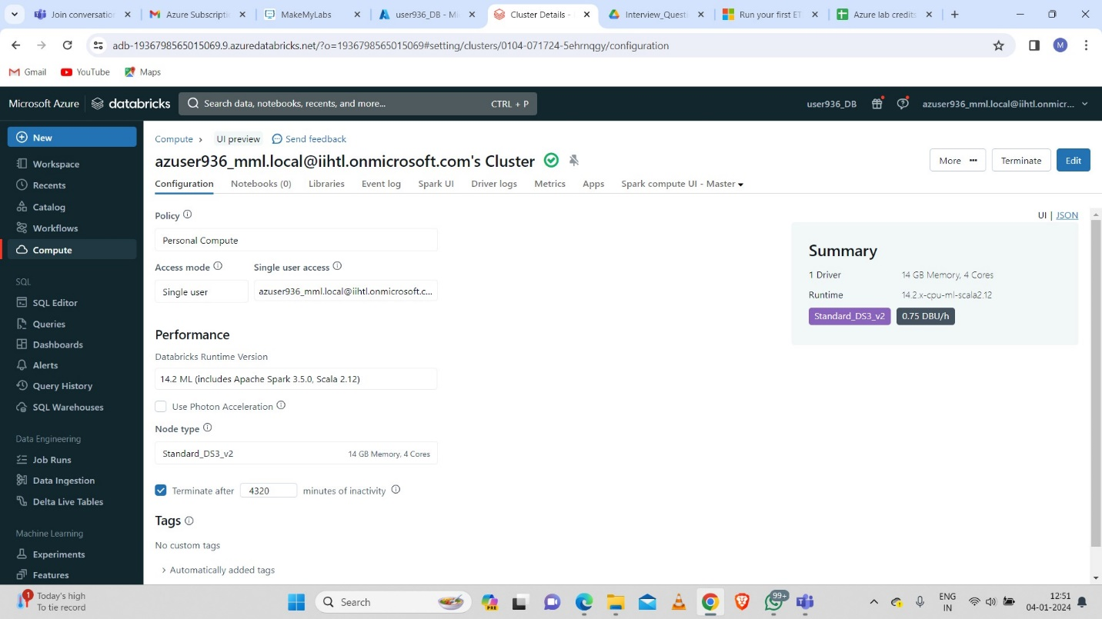

Step-2: Creating a Databricks Notebook

Click on “+new” tab and click on notebook to create a new notebook.

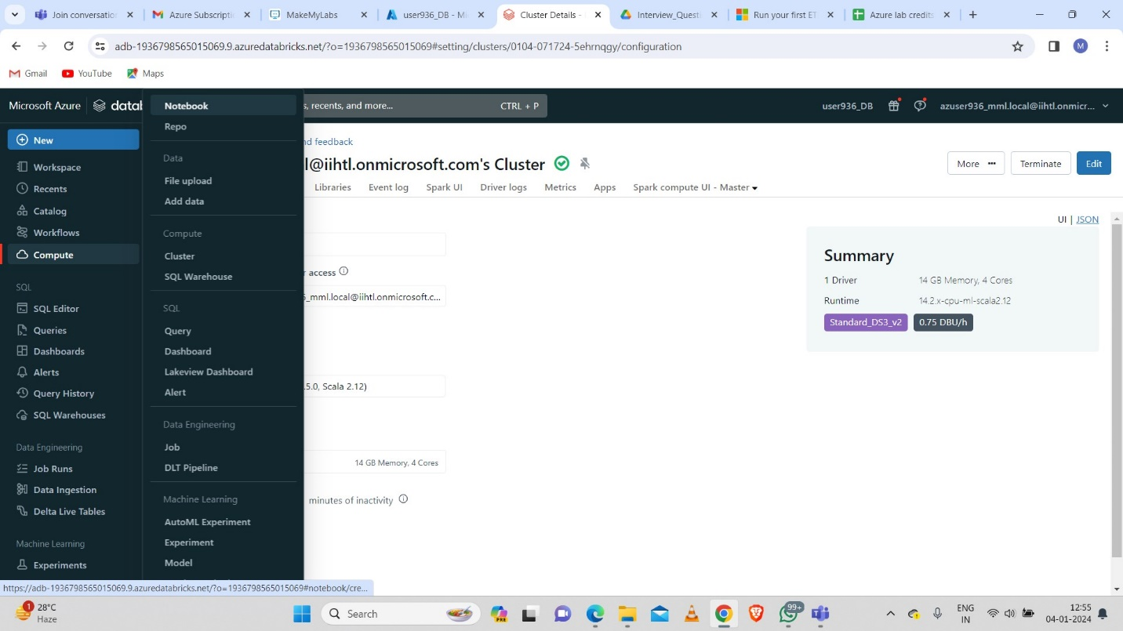

Step-3: Configure auto loader to ingest data to delta lake

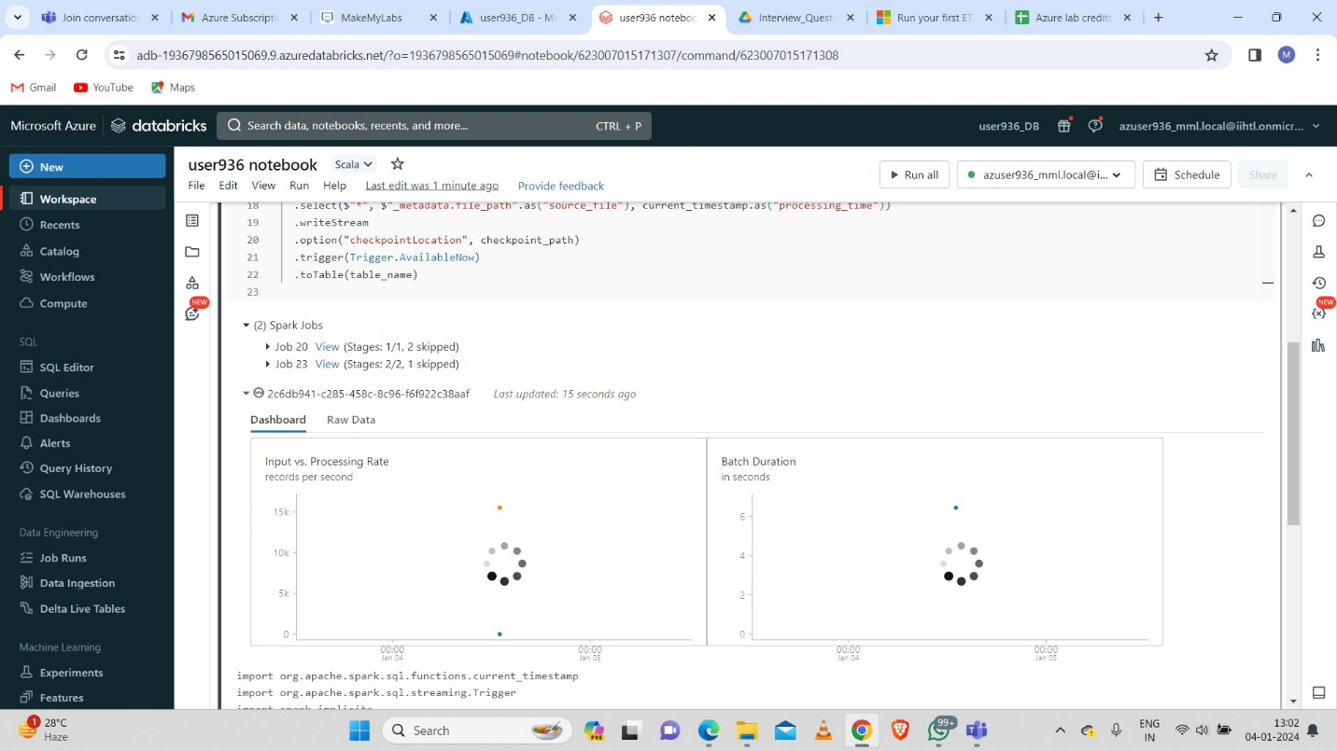

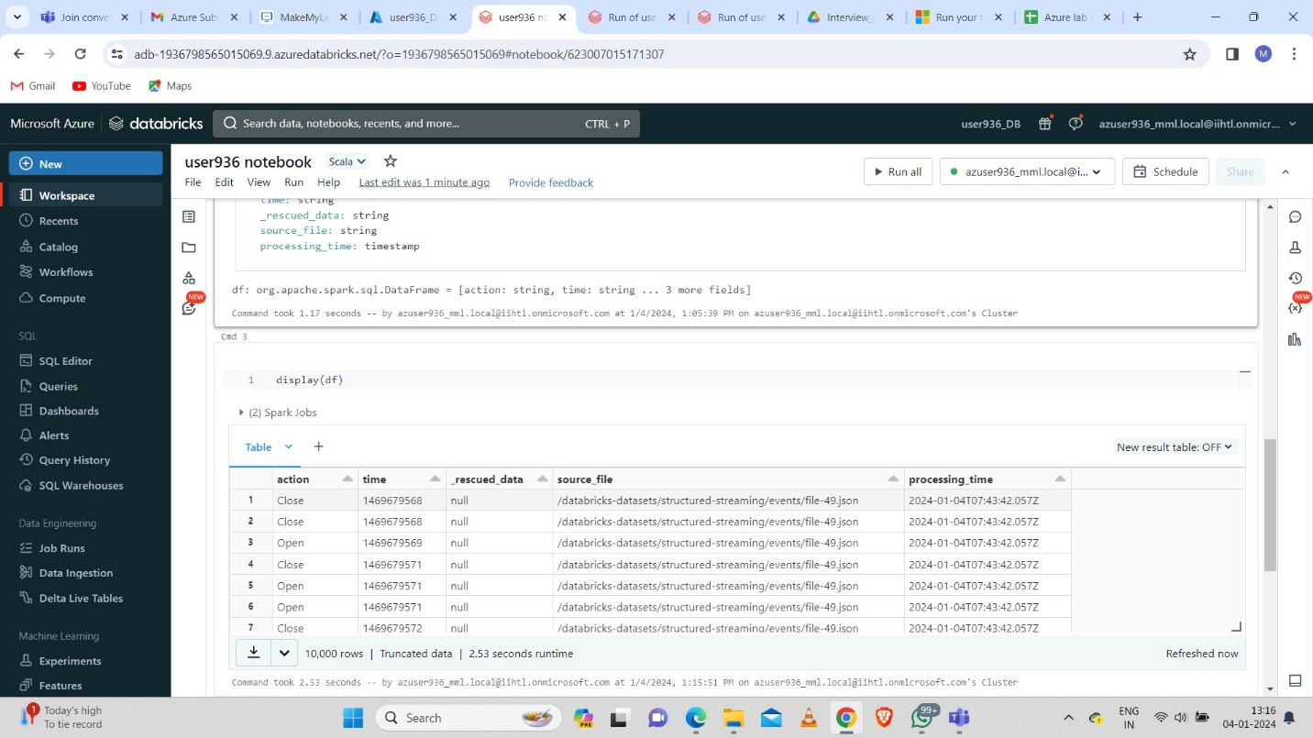

Step-4: Schedule a Job

* Click **Schedule** on the right side of the header bar.
* Enter a name for the **Job name**.
* Click **Manual**.
* In the **Cluster** drop-down, select the cluster you created in step 1.
* Click **Create**.

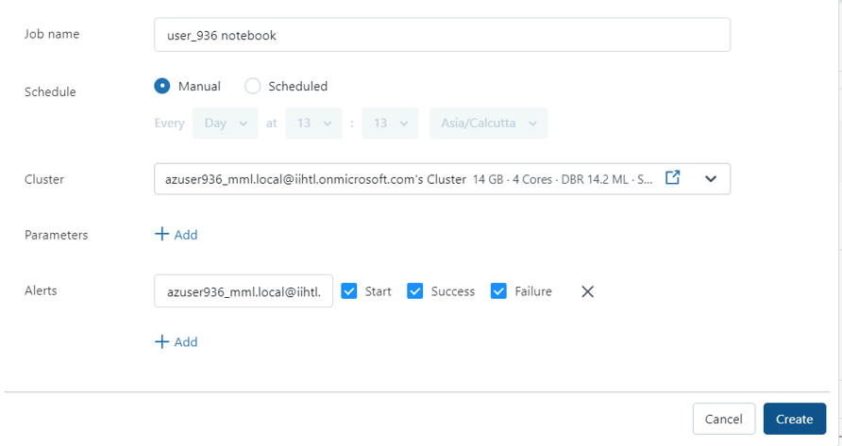

* In the window that appears, click **Run now**.

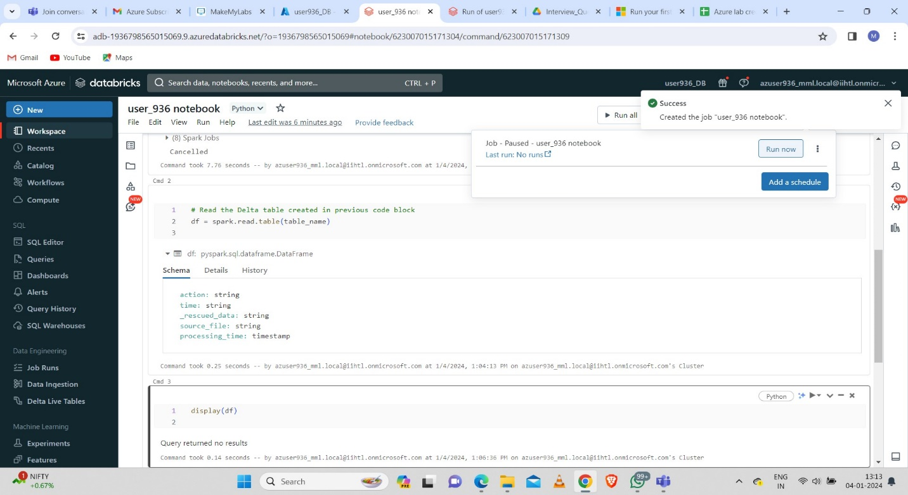

* To see the job run results, click the icon next to the **Last run** timestamp.

